Bike Renting

Sumeet Patel

26 October 2018

Contents
Chapter 1 3
Introduction 3
1.1 Problem Description 3
1.2 Problem Statement 3
1.3 Data 3
Chapter 2 5
Methodology 5
2.1 Pre Processing 5
2.1.1 Missing value analysis 14
2.1.2 Outlier analysis 15
2.1.3 Feature Selection 16
2.1.4 Feature Scaling 17
2.1.5 Sampling 18
2.2 Modelling 18
2.2.1 Model Selection 18
Chapter 3 19
Conclusion 19
3.1 Model Evaluation 19
Appendix A – Python codes 20
References 24

Chapter 1

Introduction

Problem Description
Seasonal as well as environmental changes brings in a big change on the bike renting pattern. This problem statement is targeted to predict the bike renting count daily based on seasonal and environmental settings using analytics concepts.

Problem Statement
The objective of this case is to predict the daily count of bike rented. We have a dataset that has seasonal and environmental patterns and the count of customer rented bike on a particular day whether it is weekday, weekend, holiday etc. We will develop an algorithm to predict the bike renting daily count.

Data
Data consist 731 observations and 16 variables. Following is the sample of the data set.

Table 1.1 Bike Renting (columns 1-8)
Instant | Dteday | Season | Yr | Mnth | Holiday | Weekday | Workingday
1 | 01-01-2011 | 1 | 0 | 1 | 0 | 6 | 0
2 | 02-01-2011 | 1 | 0 | 1 | 0 | 0 | 0
3 | 03-01-2011 | 1 | 0 | 1 | 0 | 1 | 1
4 | 04-01-2011 | 1 | 0 | 1 | 0 | 2 | 1

Table 1.1 Bike Renting (columns 9-16)
Weathersit | Temp | Atemp | Hum | Windspeed | Casual | Registered | Cnt
2 | 0.344167 | 0.363625 | 0.805833 | 0.160446 | 331 | 654 | 985
2 | 0.363478 | 0.353739 | 0.696087 | 0.248539 | 131 | 670 | 801
1 | 0.196364 | 0.189405 | 0.437273 | 0.248309 | 120 | 1229 | 1349
1 | 0.2 | 0.212122 | 0.590435 | 0.160296 | 108 | 1454 | 1562

Following are the given 13 independent variables

- Instant – record index
- Dteday – date
- Season – Sesaon(1-springer, 2-summer, 3-fall, 4-winter)
- Yr – year (0-2011, 1-2012)
- Mnth – month (1-12)
- Holiday - whether day is holiday or not (extracted from Holiday Schedule)
- Weekday - Day of the week
- Workingday - If day is neither weekend nor holiday is 1, otherwise is 0.
- Weathersit - 1: Clear, Few clouds, Partly cloudy, Partly cloudy
2: Mist + Cloudy, Mist + Broken clouds, Mist + Few clouds, Mist
3: Light Snow, Light Rain + Thunderstorm + Scattered clouds, Light Rain + Scattered clouds
4: Heavy Rain + Ice Pallets + Thunderstorm + Mist, Snow + Fog
- Temp - Normalized temperature in Celsius. The values are derived via (t-t_min)/(t_max-t_min), t_min=-8, t_max=+39 (only in hourly scale)
- Atemp - Normalized feeling temperature in Celsius. The values are derived via (t-t_min)/(t_maxt_min), t_min=-16, t_max=+50 (only in hourly scale)
- Hum - Normalized humidity. The values are divided to 100 (max)
- Windspeed - Normalized wind speed. The values are divided to 67 (max)

Out of 13 independent variables seven are categorical: season, yr, mnth, holiday, weekday, workingday, weathersit

And 4 continuous variables: temp, atemp, hum, windspeed.

And the target variable is ’count’ (three variables – casual count, registered count and total count) which we have to predict after developing model.

- Casual - count of casual users
- Registered - count of registered users
- Cnt - count of total rental bikes including both casual and registered
All the three are continuous varibales. As we have to predict total count so we will develop our model on total count which is the sum of the casual and registered users.

Chapter 2

Methodology

2.1 Pre Processing
After checking the unique values we came concluded that following variables are categorical. So converting them from numeric to object.
- Season
- Year
- Month
- Holiday
- Weekday
- Workingday
- Weathersit

Let’s have a look at all the continuous variables and their description.

Table 2.1 Summary before treating outliers
Variables | Std | Mean | Median | Min | Max | Count | Type | Unique
temp | 0.183051 | 0.495385 | 0.498333 | 0.059130 | 0.861667 | 731 | Float | 499
atemp | 0.162961 | 0.474354 | 0.486733 | 0.079070 | 0.840896 | 731 | Float | 690
hum | 0.142429 | 0.627894 | 0.626667 | 0 | 0.972500 | 731 | Float | 595
windspeed | 0.077498 | 0.190486 | 0.180975 | 0.022392 | 0.507463 | 731 | Float | 650
casual | 686.62248 | 848.176471 | 713 | 2 | 3410 | 731 | Integer | 606
registered | 1560.2563 | 3656.172367 | 3662 | 20 | 6946 | 731 | Integer | 679
cnt | 1937.2114 | 4504.348837 | 4548 | 22 | 8714 | 731 | Integer | 696

We will see the frequency distribution of categorical variables.
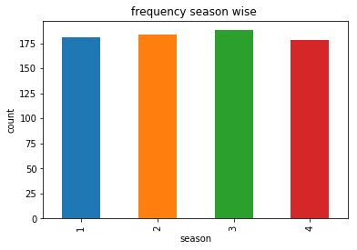
Almost all the seasons have approximately equal number of observations.

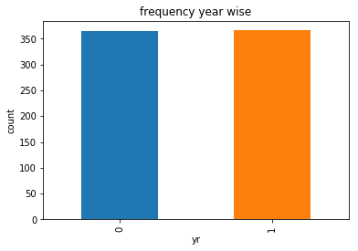
Both the years 2011 and 2012 have approximately equal number of observations.
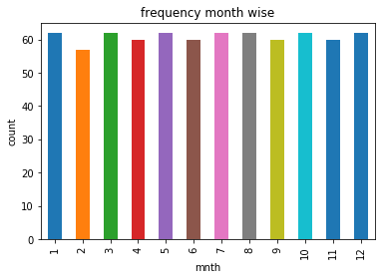
Except month number 2 all other months have a count of observations of 60 or more.
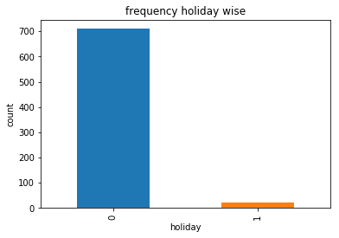

Only a few observations accounted on the days which were holidays.
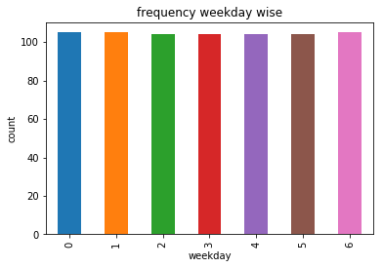
All the weekdays carry almost equal number of observations.

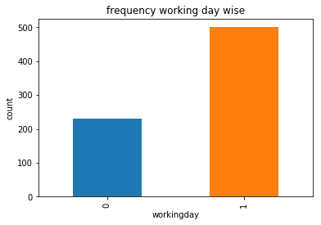
Working days are more, almost double, as compared to non-working days.
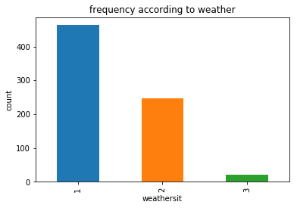
Majorly we have a ‘Clear’ weather denoted by ‘1’ followed by ‘2’ which denotes ‘Mist+Cloudy’ weather and a few observations on Light rainy days denoted by ‘3’.

Now we will plot histogram to understand the numerical distribution of the continuous variables.

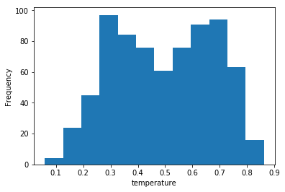

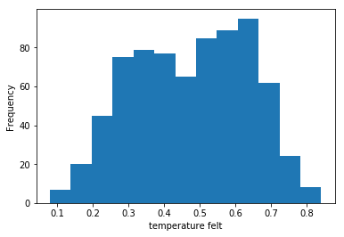

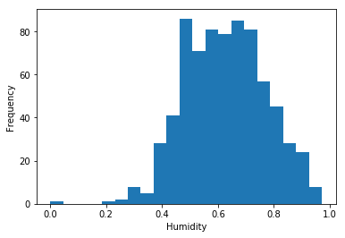

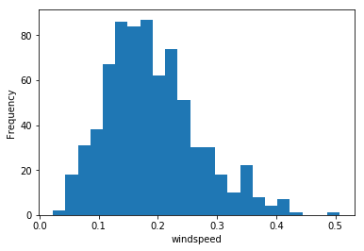

After looking at the plots we concluded that ‘temp’ and ‘atemp’ seems normally distributed while skewness in ‘hum’ and ‘windspeed’ shows presence of outliers.

Let’s see the proportion of casual and registered users w.r.t. categorical variables.
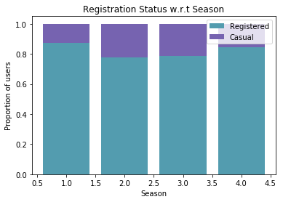
Season 2 and 3 have more number of casual users than 1 and 2.
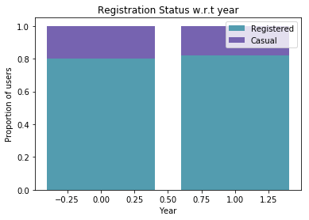
The proportion is almost similar in both the years.

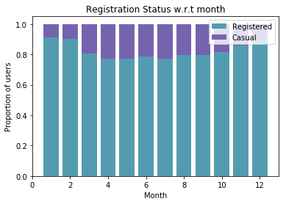
From 3rd month onwards there is an increase in the casual users count and it decreases around 8th and 9th month.
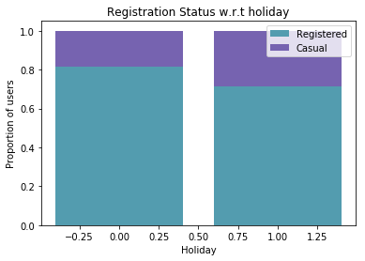
Casual users increase when it’s a holiday suggests the plot.

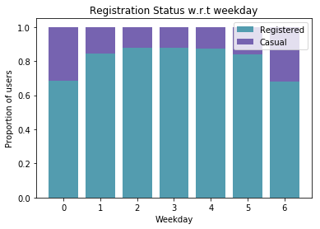
On 0th and 6th weekday there is an increase in the number of casual users.
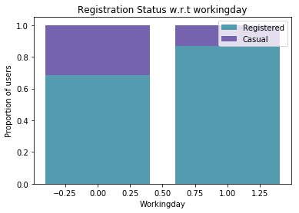

If it’s not a working day, as per the plot, casual users will increase.

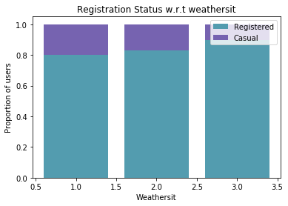

Clear weather attracts more number of casual users than rainy.

2.1.1 Missing value analysis
No missing values present in the dataset.

2.1.2 Outlier analysis

To detect the outliers in the continuous variables we have plotted boxplots. As we concluded according to the histogram, there are no outliers in the variables ‘temp’ and ‘atemp’. While those skewed ones had outliers. So we capped the outliers with 1st and 98th percentile values in ‘hum’ and ‘windspeed’ respectively.

Following is the summary in the form of boxplot of the dataset before and after treating the outliers.
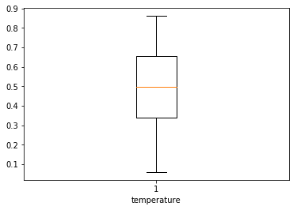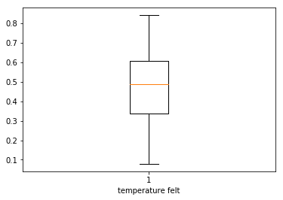

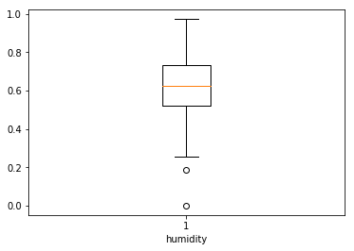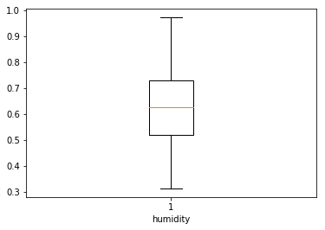
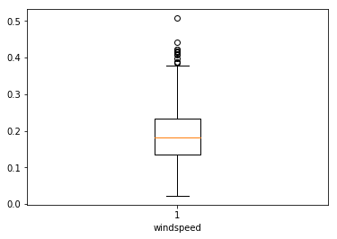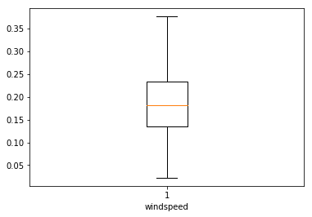

As the dependent variable is continuous, we will do regression analysis. So will create dummies for the following independent categorical variables.
- Season,
- year,
- month,
- weekday, and
- weathersit.
After creating dummies we will drop the original variables. We will also drop ‘instant’ and ‘dteday’ variable as they both contain unique 731 values.

2.1.3 Feature Selection

Here we will check the correlation within the continuous variables through correlation plot. If the continuous predictive variables are correlated to any other than we will try to eliminate in between those variables which are highly correlated. We will plot the correlation among all the variables as all are now in continuous form.
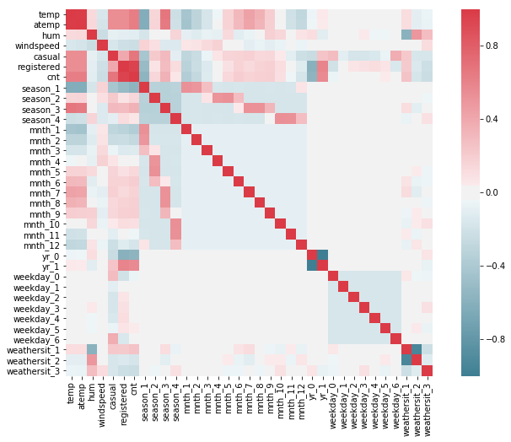

From the above plot we can see that temp and atemp are highly positively correlated. We will drop ‘atemp'. Registered and cnt are also highly correlated. But we will drop casual and registered both, as we have to develop our model to know the daily total count. ‘yr_0’ and ‘yr_1’ are negatively correlated and ‘weathersit_1’ and ‘weather_2’ are also negatively correlated. So we will drop ‘yr_1’ and ‘weathersit_2’. There are also a few other variables correlated but there is no strong correlation among those.

2.1.4 Feature Scaling
Data provided already has normally distributed values.

2.1.5 Sampling
As our target variable is continuous we will use the simple random sampling method and create two datasets out of the existing data namely – train and test. It will be divided so that train will contain 80% of the dataset. On train dataset we will train the algorithm and test dataset we will perform the test.

2.2 Modelling

2.2.1 Model Selection
After all the pre-processing of the data now we will build our model using different machine learning algorithms. The dependent variable is continuous, so the predictive analysis that we can perform is Regression. We will use following machine learning algorithms to develop our model.

- Decision tree – it is a decision support tool that uses a tree-like graph or model of decisions and their possible consequences, including chance event outcomes, resource costs, and utility.

- Random Forest – it operates by constructing a multitude of decision trees

- Linear regression – it is a linear approach to modelling the relationship between a continuous dependent variable and one or more explanatory variables.

Chapter 3

Conclusion

3.1 Model Evaluation

Now that we have a few models for predicting the target variable, we need to decide which one to choose. There are several criteria that exist for evaluating and comparing models. We can compare the models using any of the following error matrix:

- MAE – mean absolute error
- MAPE – mean absolute percentage error
- MSE – mean square error
- RMSE – root mean square error

3.2 Model Selection

We will compare all the models on different parameters.

Parameter | Decision tree | Linear regression | Random Forest
MAPE | 42.51% | 16.54% | 21.78%
MSE | 1530736.26 | 570959.29 | 577018.63
RMSE | 1237.23 | 755.62 | 759.62

MAPE = (100/n){(Actual-Predicted)/Actual)}

MSE = (1/n){(Actual-Predicted)^2}

RMSE = (√MSE)

n=Total number of observations

The company would lose on revenue if bikes will be less than the demand. So we will try to minimise the error and predict as accurate as possible. From the above table we can see that Linear Regression model gives us values which are nearer to actual values.

Appendix A – Python codes
#import libraries
import pandas as pd
import numpy as np
import os
import matplotlib.pyplot as plt
import seaborn as sns
from scipy.stats import chi2_contingency

#set workingdirectory
os.chdir("G:\edwisor")

#get workingdirectory
os.getcwd()

#load data
data = pd.read_csv("day.csv", sep = ',')

#see first 5 observations
data.head()

#see no of rows and columns
data.shape

#see data type and count
data.info()

#number of unique values in all variables
data.nunique()

#convert numeric to object
data['season'] = data['season'].astype(object)
data['yr'] = data['yr'].astype(object)
data['mnth'] = data['mnth'].astype(object)
data['holiday'] = data['holiday'].astype(object)
data['weekday'] = data['weekday'].astype(object)
data['workingday'] = data['workingday'].astype(object)
data['weathersit'] = data['weathersit'].astype(object)

#summary of the numeric variables
data.describe()

#bargraph
var = data.groupby('season').season.count()
fig = plt.figure()
ax1 = fig.add_subplot(1,1,1)
ax1.set_xlabel('season')
ax1.set_ylabel('count')
ax1.set_title("frequency season wise ")
var.plot(kind='bar')

#histogram
plt.hist(data['temp'], bins='auto')
plt.xlabel('temperature')
plt.ylabel("Frequency")
# Calculate the mean number of check outs for each day by
# registration status
mean_by_reg_co_day = data[['season', 'registered', 'casual']].groupby('season').mean()
# Calculate proportion of each category of user for each day
mean_by_reg_co_day['total'] = mean_by_reg_co_day['registered'] + mean_by_reg_co_day['casual']
mean_by_reg_co_day['reg_prop'] = mean_by_reg_co_day['registered'] / mean_by_reg_co_day['total']
mean_by_reg_co_day['casual_prop'] = mean_by_reg_co_day['casual'] / mean_by_reg_co_day['total']

# Define a function for a stacked bar plot
def stackedbarplot(x_data, y_data_list, y_data_names, colors, x_label, y_label, title):
_, ax = plt.subplots()
# Draw bars, one category at a time
for i in range(0, len(y_data_list)):
if i == 0:
ax.bar(x_data, y_data_list[i], color = colors[i], align = 'center', label = y_data_names[i])
else:
# For each category after the first, the bottom of the
# bar will be the top of the last category
ax.bar(x_data, y_data_list[i], color = colors[i], bottom = y_data_list[i - 1], align = 'center', label = y_data_names[i])
ax.set_ylabel(y_label)
ax.set_xlabel(x_label)
ax.set_title(title)
ax.legend(loc = 'upper right')

# Call the function to create plot
stackedbarplot(x_data = mean_by_reg_co_day.index.values
, y_data_list = [mean_by_reg_co_day['reg_prop'], mean_by_reg_co_day['casual_prop']]
, y_data_names = ['Registered', 'Casual']
, colors = ['#539caf', '#7663b0']
, x_label = 'Season'
, y_label = 'Proportion of users'
, title = 'Registration Status w.r.t Season')

#boxplot for outliers
%matplotlib inline
plt.boxplot(data['temp'])
plt.xlabel('temperature')

#calculate 1th %ile
a = np.array(data['hum'])
p = np.percentile(a, 1) # return 1th percentile, e.g median.
print(p)

#replace values in the variable
for i in range(len(data)):
if data["hum"].loc[i]<0.31212510000000004:
data["hum"].loc[i]=0.31212510000000004

##Create dummies for categorical variables
cat_names = ["season",'mnth', "weekday",'weathersit']

for i in cat_names:
temp = pd.get_dummies(data[i], prefix = i)
data = data.join(temp)

#delete variables
del data['season']
del data['mnth']
del data['weekday']
del data['weathersit']
del data['instant']
del data['dteday']

#defining column names
cnames=['yr','holiday','workingday','temp','atemp','hum','windspeed','casual','registered','cnt','season_1','season_2', 'season_3','season_4','mnth_1','mnth_2','mnth_3','mnth_4','mnth_5','mnth_6','mnth_7','mnth_8','mnth_9','mnth_10', 'mnth_11','mnth_12','weekday_0','weekday_1','weekday_2','weekday_3','weekday_4','weekday_5','weekday_6',
'weathersit_1','weathersit_2','weathersit_3']

#correlation
df_corr = data.loc[:,cnames]
#correlation plot
f, ax = plt.subplots(figsize=(12,8))

#Generate correlation matrix
corr = df_corr.corr()

#Plot using seaborn library
sns.heatmap(corr, mask=np.zeros_like(corr, dtype=np.bool), cmap=sns.diverging_palette(220, 10, as_cmap=True),
square=True, ax=ax)

#defining column names
columnsTitles = ['yr','holiday','workingday','temp','hum','windspeed','season_1','season_2','season_3','season_4',
'mnth_1','mnth_2','mnth_3','mnth_4','mnth_5','mnth_6','mnth_7','mnth_8','mnth_9','mnth_10','mnth_11','mnth_12',
'weekday_0','weekday_1','weekday_2','weekday_3','weekday_4','weekday_5','weekday_6','weathersit_1',
'weathersit_2','weathersit_3','cnt']

#rearranging columns
data=data.reindex(columns=columnsTitles)

#Import Libraries for decision tree
from sklearn import tree
from sklearn.metrics import accuracy_score
from sklearn.cross_validation import train_test_split
from sklearn.tree import DecisionTreeRegressor

#divide train and test data
train, test = train_test_split(data, test_size=0.2)

#desicion tree regression
fit_DT = DecisionTreeRegressor(max_depth=2).fit(train.iloc[:,0:31], train.iloc[:,31])

#apply on test data
predictions_DT = fit_DT.predict(test.iloc[:,0:31])
#calculate MAE,MSE,RMSE

from sklearn import metrics

print('Mean Absolute Error:', metrics.mean_absolute_error(test.iloc[:,31], predictions_DT))
print('Mean Squared Error:', metrics.mean_squared_error(test.iloc[:,31], predictions_DT))
print('Root Mean Squared Error:', np.sqrt(metrics.mean_squared_error(test.iloc[:,31], predictions_DT)))

#Calculate MAPE
def MAPE(y_true, y_pred):
mape = np.mean(np.abs((y_true - y_pred) / y_true))*100
return mape

MAPE(test.iloc[:,31], predictions_DT)

# ## Linear Regression
#Import libraries for LR
import statsmodels.api as sm

y = train.iloc[:,31]
x = train.iloc[:,0:31]

# Train the model using the training sets
model = sm.OLS(y, x.astype(float)).fit()

# Print out the statistics
model.summary()

# make the predictions by the model
predictions_LR = model.predict(test.iloc[:,0:31])

#randomforest model

from sklearn.ensemble import RandomForestRegressor

regressor = RandomForestRegressor(n_estimators=20, random_state=0)
regressor.fit(train.iloc[:,0:31], train.iloc[:,31])
y_pred = regressor.predict(test.iloc[:,0:31])

References

https://edwisor.com/

https://www.analyticsvidhya.com/

http://www.statisticssolutions.com/

https://en.wikipedia.org/wiki/

https://towardsdatascience.com/

https://github.com/

https://www.datacamp.com/

https://stackoverflow.com/

https://www.khanacademy.org/

https://www.listendata.com/

https://www.hackerearth.com/

https://stackabuse.com/

